**Experiment-2**

**Design and Configuration of Star Topologies using Packet Tracer.**

Give Ip address for each pc

IP address for pc0:192.168.0.1

IP address for pc1: 192.168.0.2

IP address for pc2: 192.168.0.3

IP address for pc3: 192.168.0.4

Allocate the messages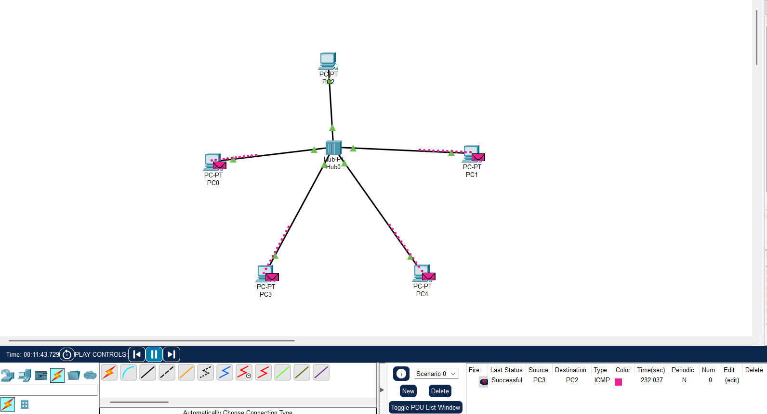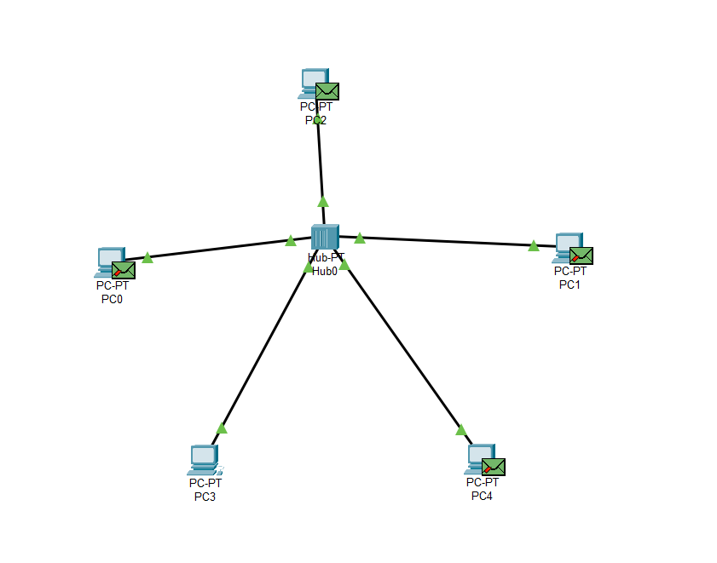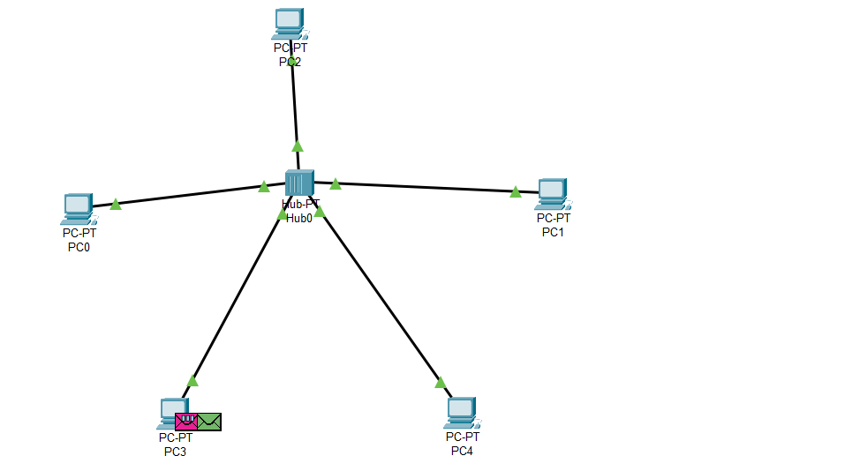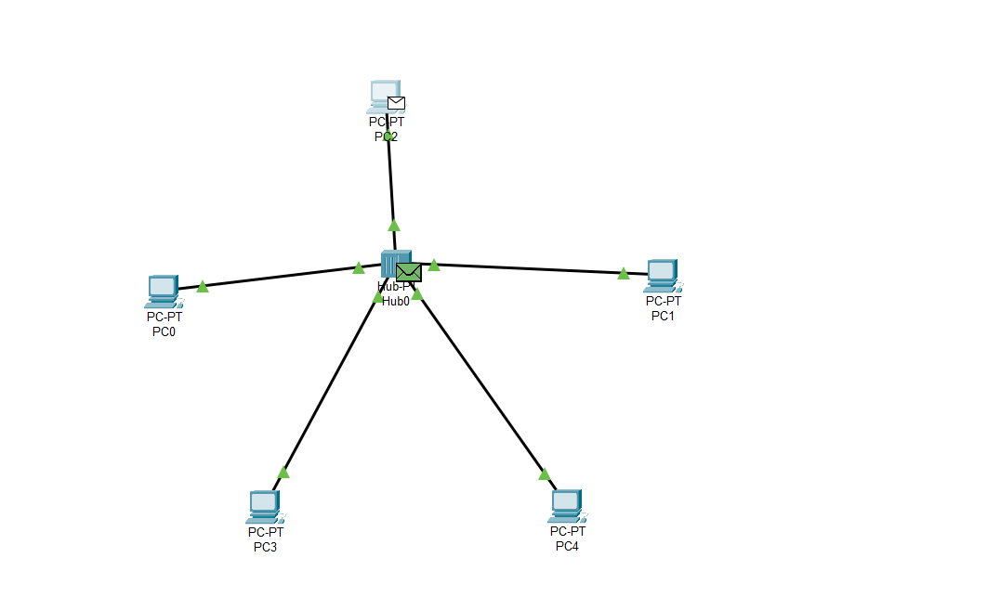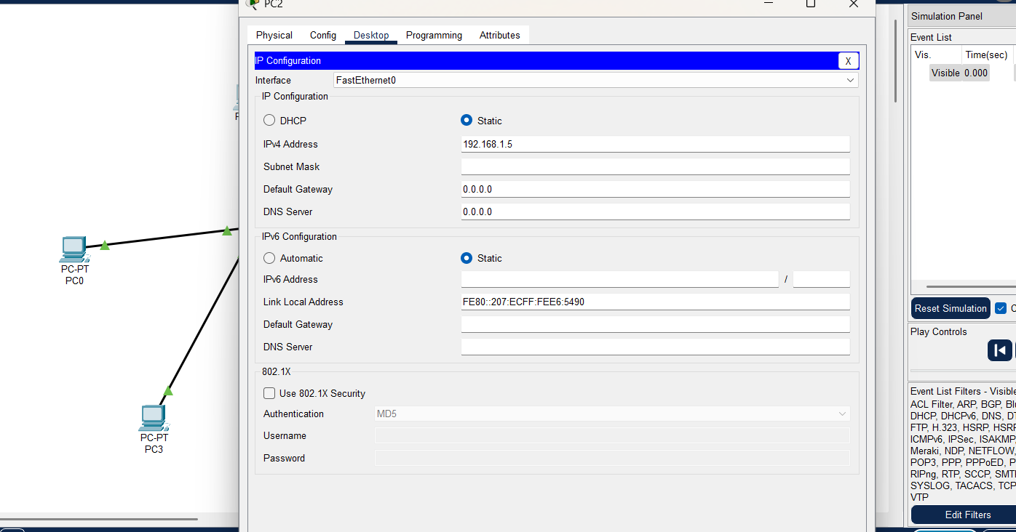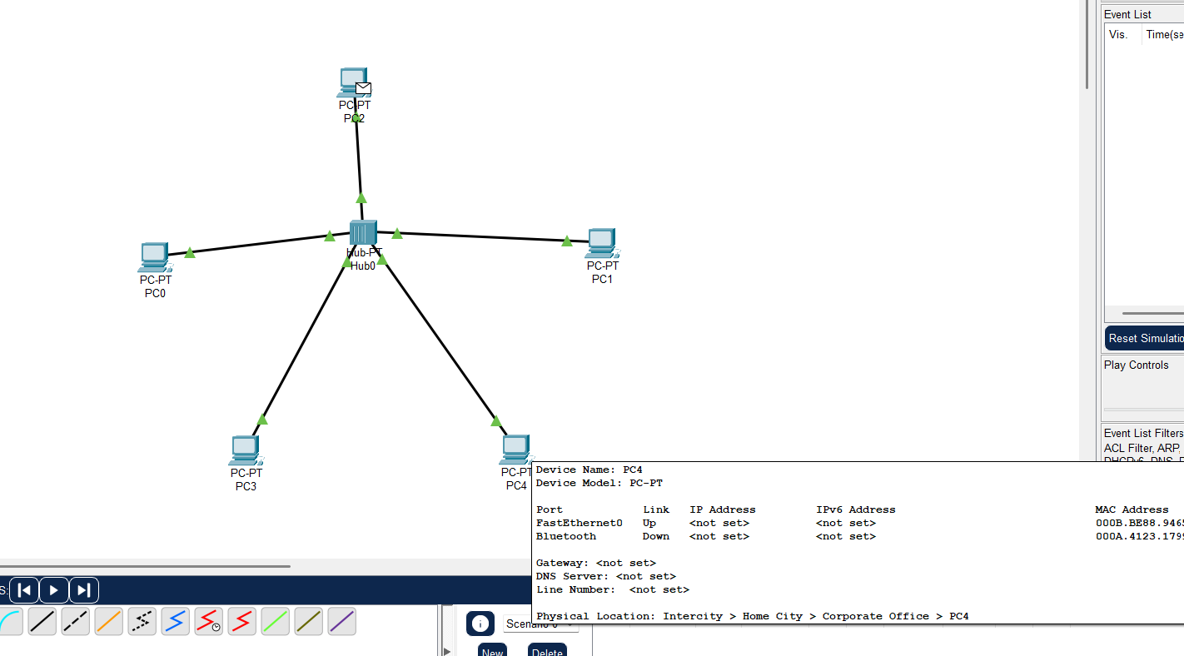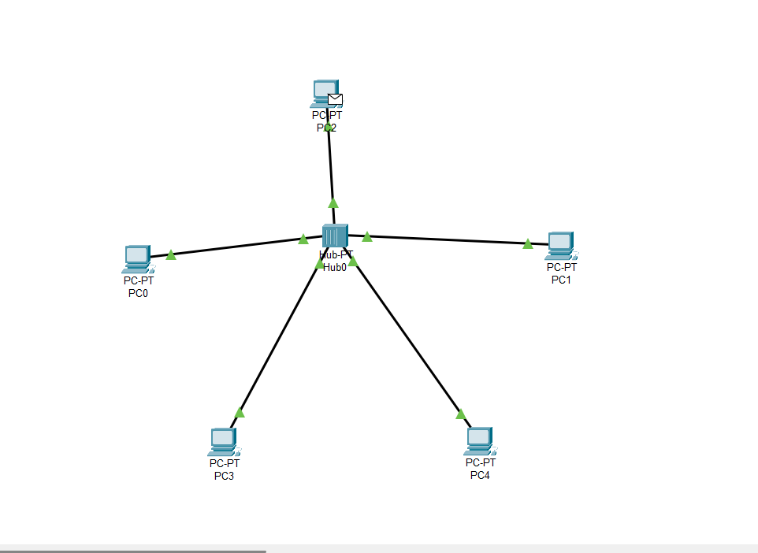

**Output:**

